WHAT CAN YOU LEARN FROM A BUILDING?
Ksar Said is a beautiful place.
This is a palace of the Beys. They were the rulers of Tunisia when it was part of the Ottoman empire. Although the Beys ruled as part of the Ottoman empire, they wanted to be independent. Their architects and builders were not only influenced by Ottoman styles, but by many different ideas from Tunisian history. They had the freedom to include those ideas in the design of the palace.
In this mission, you are going to work through the activities to help the Bey to identify the styles in his Palace. To help you, you have been given a guide to architectural styles, which you can download from the link on the mission page.

TASK
Use the guide to architectural styles to work out which architectural influences you can see in each hotspot. You may see more than one influence in each hotspot. Complete the table below.
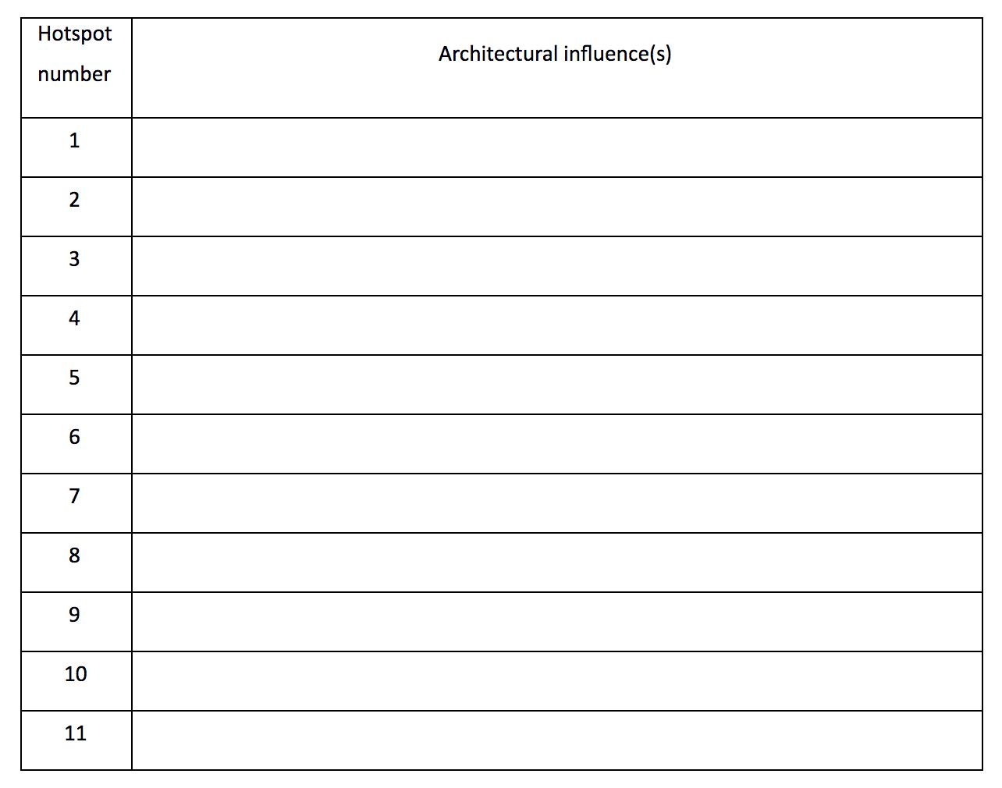

TASK
Try to make a list of features to help you recognise the architectural styles. Compare the styles by filling in the Table below. The first two lines have been done for you. You can include as many rows as you like. Copy and complete the table below. You can add more rows.
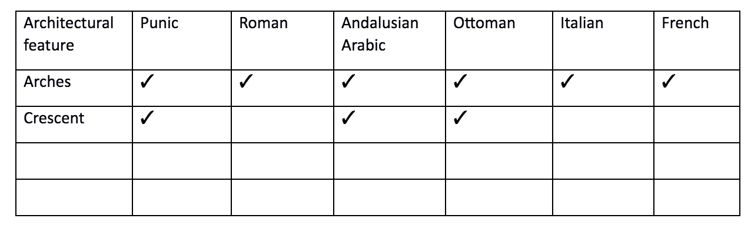

TASK
Write a series of questions, which can be answered only yes or no, to help the Bey identify the architectural style he is looking at.
