WHAT’S THAT TILE?
This mission is broken, and we need your help to fix it. It’s all about the tiles you can see on the walls in the Palais. Beautiful aren’t they! Scroll down to work out what the problem is.

TASK
Walk around the palace and click on the hotspots on the tiles. When you click, it tells you which part of Tunisia’s history influenced its design. But some of the hotspots are missing, and for some, the origin isn't clear - it just says Qallaline, which is a mix of historical influences. It should tell you which part of Tunisia's history influenced the tile's design most strongly. We don’t know why, but we think the designer just didn’t know enough about the tiles’ origins to finish it off.

TASK
Look at the tiles on the Ceramics mission page. Each tile has a letter, which is revealed when you hover over it. Write down the letters of the three tiles which are most similar to each other. From the remaining tiles, write down the letters of two tiles which are very different to each other. For the remaining four tiles, write down the letters of two tiles which are very different, and two tiles which are more similar.

TASK
When you thought about the similarities, which criteria did you use? For example, you may have put the tiles together according to colour. Make a list of the criteria now. Choose just one of those criteria, and write down the letters of the tiles in order, to show how closely they meet the criterion. For example, if the criterion was 'blue', the bluest tile would be at the start of the list of tiles, and the least blue tile at the end of the list.

TASK
Download the Ceramics guide, and look at the pictures of tiles from each of the cultures which has influenced Tunisia. Using the drop-down menu, try to decide which tile matches each style most closely. This is exactly what historians and archaeologists do, when trying to work out the origin of tiles and other decorations they find in buildings. You can even do this on the next few pages, as well as on the Mission page itself.

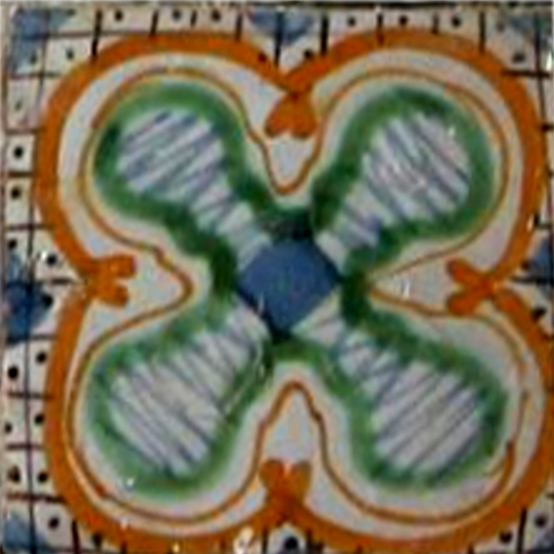

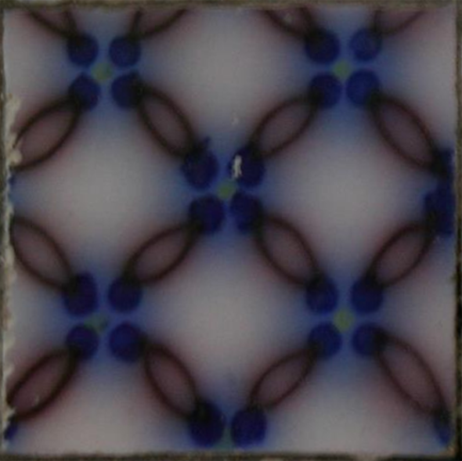

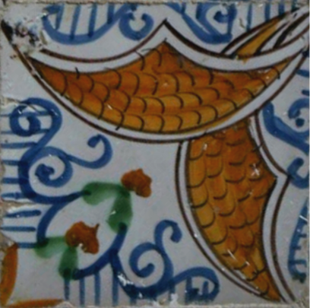

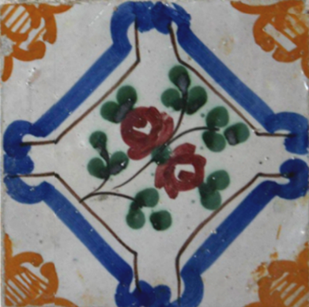

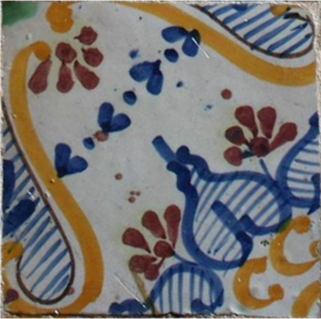

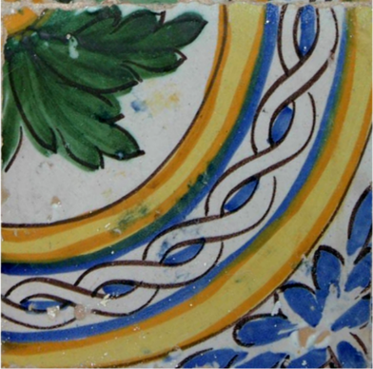

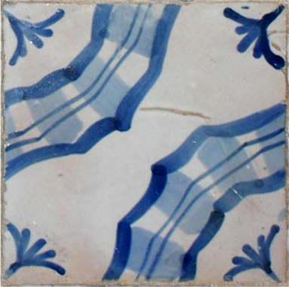

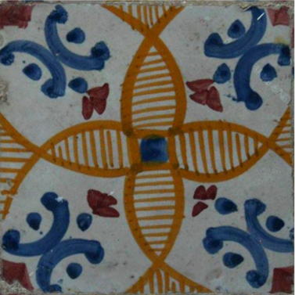

TASK
Finally, answer these questions:
- Write down what features of the designs were most important to you in matching a tile with an origin.

- Suggest what evidence you could search for to help confirm whether your choices were right or wrong.

