WHY DO YOU EAT WHAT YOU EAT? WHY DO YOU EAT WHAT YOU EAT?
Have you ever wondered where your food comes from? You may not realise it, but your food looks very different to food eaten in many other Arab countries. Look at the hotspots in the Palace below. You should recognise most of the foods there as Tunisian. But the foods in each hotspot came to Tunisia from different countries at different times. This is because different people came to Tunisia at different times, and brought their food with them.

TASK
Look at the foods in each hotspot. Use the clues in each hotspot to work out who brought those foods to Tunisia.
Copy and complete the table below. This table is like a timeline, showing the influences on Tunisian food over time, from Berber to French. Write the name of each food in the boxes on the left. Using the evidence from each hotspot, colour in the boxes to show who brought each food to Tunisia.

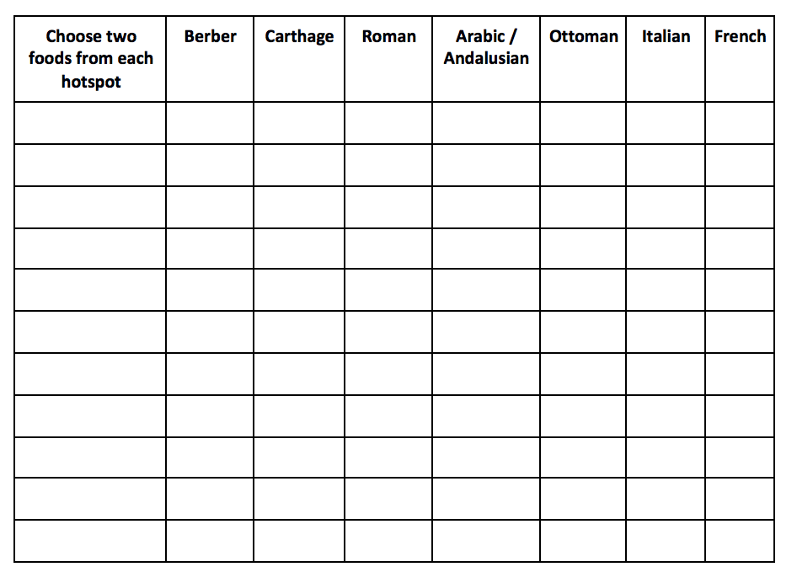TASK
Now use the information in the timeline to make five predictions about food in Tunisia. For example, because olives were grown in Roman times and olive oil is produced now, you may predict that:
‘Olive oil has been made in Tunisia ever since Roman times’
You may not have evidence from each era of Tunisian history, but you would have made a sensible prediction.
Copy and complete the table to fill in your predictions. Next to each prediction write down what evidence you would need to prove it was true.
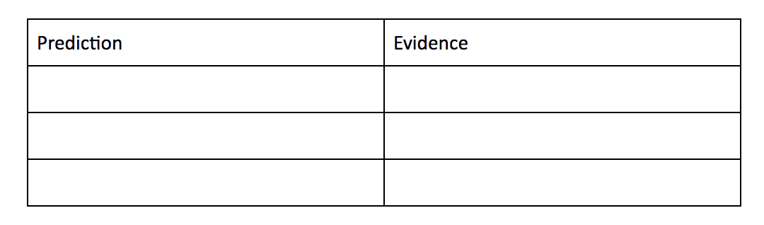

TASK
Design a menu which includes food from every set of people who have influenced Tunisian cuisine.
